Milestone 3

Dynamic Website Prototype

11, 2018

WEB601

Dean Stanley-Hunt

2018

Contents

Site Goals 2

Mission or purpose 2

Short and long term goals 2

Intended Audiences 2

Why will people come to the website? 2

Define the User Experience 3

Define the Audience (Personas) 3

Audience Scenarios 5

Competitive Analysis 7

Site Content 22

Identify Content and Functional Requirements 22

Site Structure 23

Architectural Blueprint 23

Define navigation 24

Visual Design 24

Layout Wireframes 24

Design Sketches and Page Mock ups (in HTML,CSS,PHP,JS) 30

Updates to Information Architecture for Milestone 2 37

Creating & Connecting the Database 37

Implementing Login & Registration through the Database 38

Implement a Competition Form & Thanks 38

Time to Play a Game? 40

Updating Account Profiles through the Database 43

Updates to Information Architecture for Milestone 3 45

Competition JQuery Animation! 45

Tutorial Comments & First AJAX 46

Form Validation & Accepted Examples! 48

Tracking User Navigation, Trainer Statistics and JQuery AJAX! 51

Pushing the Website and Database to NewSimland! 52

# Site Goals

## Mission or purpose

This dynamic website is being built for educational purposes to help secondary school aged individuals who may be struggling with simple mathematics and want to get up to speed in order to do better at mathematics during those important secondary school years for which mathematics takes a turn towards doing algebra and quadratic equations.

While this website initially will not have support towards learning material at secondary school, it will provide a base platform for expansion in future, that new secondary school students can use to check where their skill level is, and how ready any student is for moving onto the next level of mathematics.

If a teacher notices a new secondary student struggling this website could potentially be used to help the student catch up and get on top of the mathematics game!

## Short and long term goals

Short-term this website will be developed keeping in mind Information Architecture aiming at implementing a Model, View & Controller (MVC) web application using HTML, CSS, PHP, Javascript, and AJAX, with session retention and onto the use of a Database Management System. The websites will initially have mathematical tutorials and challenges to complete in order to learn and put into practice proof of concept solving equations comprising of addition, subtraction, multiplication & division.

Long-term this website is to become capable of tracking users progress, support logging in accounts and provide statistics to users on an overall and activity by activity basis. Potentially the ability to add sub-users to an account so parents or teachers can add their kids or students and monitor accomplishments and learning to aid supporting secondary schoolers mathematics skills while trying to be fun for the learner at the same time, with plenty of support to customize tutorial activities.

## Intended Audiences

The intended audience for the website is secondary school-aged children and teenagers while providing a platform for parents and teachers to help aid students who may be struggling with simple mathematics and need to get up to speed but find it daunting instead of fun. Others from primary and intermediate schoolers to adults will be able to use the website too, either for mastering the basics earlier in their educational years or brushing up on forgotten knowledge as an adult. But primarily the targeted audience is Secondary schoolers, Teachers, and Parents!

## Why will people come to the website?

To get help with aiding and supporting a trackable mathematical learning environment from home or in the classroom for parents, teachers and students alike, making learning easier, interactive and fun!

# Define the User Experience

## Define the Audience (Personas)

Students

Demographic:

Students are primarily identified to be in Secondary/High School aged 12-18 years and can be any gender. Education includes previous attendance to Primary and Intermediate Schools. Part time occupation involving cash counting and handling is a possibility for Students 15 or over.

Psychographic:

The goals of Students are to become better educated and ready for transition into the world as independent individuals and young adults whom will likely go directly into work life or tertiary education. Students are expected to be given tasks like homework to complete outside of school hours and tasks such as writing essays, doing a test or sitting exams while at school. Students can be involved in extracurricular tasks such as sports training and events. The motivation for Students comes from personal and parental desires, with encouragement from school staff such as teachers. But often motivation can be the biggest downfall for a Student.

Webographics:

Students have been exposed to computers, tablets or even smartphones with likely a few years of experience either using devices at home, school or even on the go! Some Students are likely smartphone or tablet owners and will be highly competent in the usage of such devices on a daily or weekly basis, with a tendency towards social media’s such as Facebook, Twitter or Instagram.

Teachers

Demographic:

Teachers are primarily identified to be employed teaching Secondary/High School Aged Students and can be any gender. Education includes all compulsory schooling followed by completing a Teaching Degree at a tertiary level. Teachers may be new to teaching or experienced from previous or current long-term employment.

Psychographic:

The goals of a Teacher are to educate Students according to national standards for any given year of learning while stimulating young minds towards thinking independently and freely but informatively. Teachers are expected to undergo tasks like organizing, planning and scheduling classes, marking in-class tests and following a lesson plan to ensure all requirements under national standards are met. Some Teachers may have children attending the same school as their employment. The motivation for Teachers often comes from personal desires, a love for educating and working with the younger generation or financial security. Often a Teacher lacking motivation can negatively influence Students.

Webographics:

Teachers have been exposed to computers, tablets and more than likely own smartphones or all 3 with many years of experience either using devices at home, school or in work environments! While some Teachers may already be using such devices in the learning environment on a daily or weekly basis, with a tendency towards better-educating Students through visual, audio and physical interactivities.

Parents

Demographic:

Parents are primarily identified to have children that are in Secondary/High School, and Parents can be any gender. Education includes previous attendance to compulsory schooling and possibly further tertiary education. Occupation can be any form of employment or unemployed on welfare. Likely lacking the skills, knowledge, time and tools to educate their children themselves.

Psychographic:

The goals of Parents are like the goals of a Student, every Parent wants to see their child ready for transition into the world as independent individuals and hopefully progress on to tertiary education. But Parents also want a safe learning environment for their Child. Parents have everyday tasks like work, taking children to and from school, cooking, cleaning and more. Parents may have the task of encouraging and aiding their Child with completing homework outside of school hours. The motivation for Parents comes from personal desires, wanting to see their child do well in school and life in general, some Parents even pressure their Children to excel at school and become overachievers.

Webographics:

Parents have commonly become familiar with computers, tablets or even smartphones with likely a few years of experience either using devices at home or in a work environment! But some Parents may be significantly less competent than their Children due to all the changes in use of devices amongst society today compared to when the Parents were younger themselves. Parents are expected to be smartphone owners and possibly computer owners too, but competency will vary greatly as will the usage of such devices on a daily or weekly basis, with many Parents mostly using these for Online shopping, emailing and social media such as Facebook.

## Audience Scenarios

Students

Michael just turned 13 years old and is starting his first year at secondary school next week but is feeling weary about his mathematics ability since his parents have told him that in secondary school he will have different teachers for separate subjects. Previously he has always had just one Teacher and class to attend where all subjects were covered.

He is nervous after struggling through intermediate school to do basic mathematics and failing to perform during math quizzes due to time constraints as he takes a long time to complete mathematical equations, he usually gets them correct but cannot do the math work fast enough.

Michael has asked his Parents if he can get tutoring to help with his mathematics, but his Parents are unemployed, unable to afford the costs associated. Michael has a tablet he got for Christmas and would like to be able to use it for helping develop his mathematical skills in a more interactive way.

Teachers

Mrs. Richardson is a secondary school mathematics teacher aged 29 who has completed a teaching degree and is particularly interested in Design-Based Research to improve the learning environment she provides. Research has her interested in Information Technology and its possible benefits with application to a mathematical learning environment for helping with things like speed training, visualization, demonstration, lessons, testing, homework and more.

All the while providing the foundations for collecting student data for analysis, progress tracking and the ability to let her students learn mathematical knowledge and skills at the pace of each individual, able to repeat lessons until they do understand. Mrs. Richardson is also in search of alternative learning methods for the various types mathematics to be supported because ‘one size doesn’t fit all’ she says.

She has searched for an online service but failed to find anything that supports all her needs and desires for getting the most out of implementing such a drastic change in the way mathematics is taught, having found sites with good content and many of the aids desired, but they just only seem to support single user registration and login, but Mrs. Richardson wants to group and add accounts that students create into a list that she is monitoring progress for and be able to provide feedback to individual students, while viewing individual or overall statistics.

She also believes that wasting paper for written tests is a thing of the past and has been pushing for the school she works at to adopt a paperless trend, as students should have previously developed writing skills prior to secondary school, so distributing digital quiz’s or tests is under consideration.

Parents

Bobby is a Father of 3 children who are all currently at different years in secondary school, he is struggling to find work due to a criminal conviction when he was younger. His kids are ‘not the brightest bulbs’ he say’s and Bobby has very little mathematical skills himself. The school has informed Bobby that his children are all struggling to do even basic mathematics and continue to fail despite having teachers aid and individual sessions free at school to help as it’s a long dragged out process of learning.

Bobby wishes he could afford private lessons after school hours but is on welfare, he would gladly use his free time to teach his children if only he had the knowledge base and right toolset to do this with. The school has given math work book’s, but the children keep getting stuck, with Bobby unable to be any help he wishes the books could show the end answers when unable to complete equations and explain how it was derived. The children quickly become bored and lose focus easily.

Bobby wishes there was a cost-effective way to have a personal individual tutor like service for each child to help with the year they are currently in, that would help his kids to learn in a more fun interactive manner, from the comfort and safety of home, where he can see and witness first-hand the progress his children are making. But the services he has explored all cost way too much hourly for a single tutor, let alone three to have one each.

Summary of Functional Analysis for Scenarios

|  |  |  |  |
| --- | --- | --- | --- |
| **FUNCTIONALITY** | **Students** | **Teachers** | **Parents** |
| Option between Predefined or Auto generated Quiz’s and Tests | Checkmark | Checkmark | Checkmark |
| Support mathematical learning starting from the basics upwards | Checkmark | Checkmark | Checkmark |
| Assistance with mathematical speed training | Checkmark | Checkmark |  |
| Assistance with repetitive memorizing techniques | Checkmark | Checkmark |  |
| Adjustable/Customizable time constraints | Checkmark | Checkmark |  |
| Enforcement of defined time constraints |  | Checkmark |  |
| Tutorials combining theoretical and practical elements | Checkmark | Checkmark | Checkmark |
| Low cost and affordable for all | Checkmark | Checkmark | Checkmark |
| Support for multiple device types | Checkmark | Checkmark |  |
| Visual/Audio aids | Checkmark | Checkmark | Checkmark |
| Demonstrations and examples | Checkmark | Checkmark |  |
| Option between Predefined or Custom self-built lessons |  | Checkmark |  |
| Interactive and fun | Checkmark | Checkmark | Checkmark |
| Support for assigning homework tasks |  | Checkmark | Checkmark |
| Data collection for record keeping, analysis and tracking progress | Checkmark | Checkmark | Checkmark |
| Support and control over lessons, tasks, and tests repeatability | Checkmark | Checkmark | Checkmark |
| Optional Alternative learning approaches |  | Checkmark |  |
| Support creating groups to add and lists relevant learners under |  | Checkmark | Checkmark |
| Support group management, task assigning and monitoring |  | Checkmark | Checkmark |
| Support Statistical results for individuals | Checkmark | Checkmark | Checkmark |
| Support Statistical results for groups |  | Checkmark | Checkmark |
| Support feedback channels to groups and individual learners |  | Checkmark | Checkmark |
| Ability to show the answer and how it can be derived when stuck | Checkmark |  | Checkmark |
| Appropriate functionality between learner and educator accounts | Checkmark | Checkmark |  |

The above table identified the needs and wants of the intended audience, functionality that is marked with a tick by all three personas are considered the highest priority compared to functionality ticked by only one of the personas. The aim long term will be to implement all of the above into the design.

## Competitive Analysis

**Website:** Math’s Is Fun

**URL:** [www.mathsisfun.com](http://www.mathsisfun.com)

**The Idea:**

“We offer mathematics in an enjoyable and easy-to-learn manner because we believe that mathematics is fun.”

**General:**

“The site aims to cover the full Kindergarten to Year 12 curriculum.”

**Quoted from:** <https://www.mathsisfun.com/aboutmathsisfun.html>

**Numbers Page**: <https://www.mathsisfun.com/numbers/index.html>

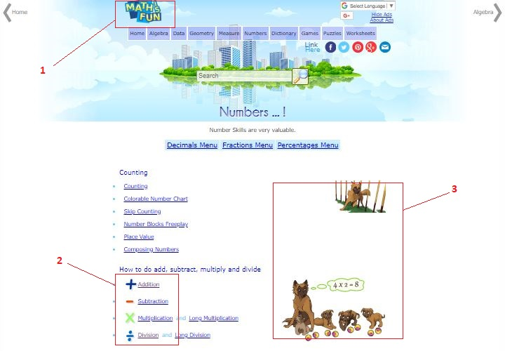

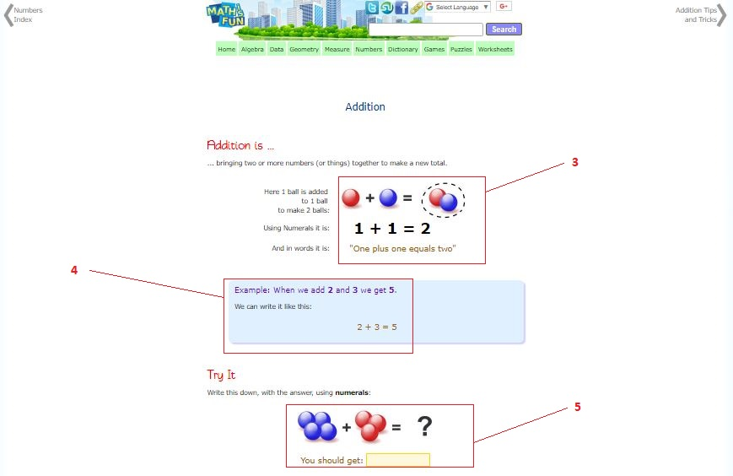

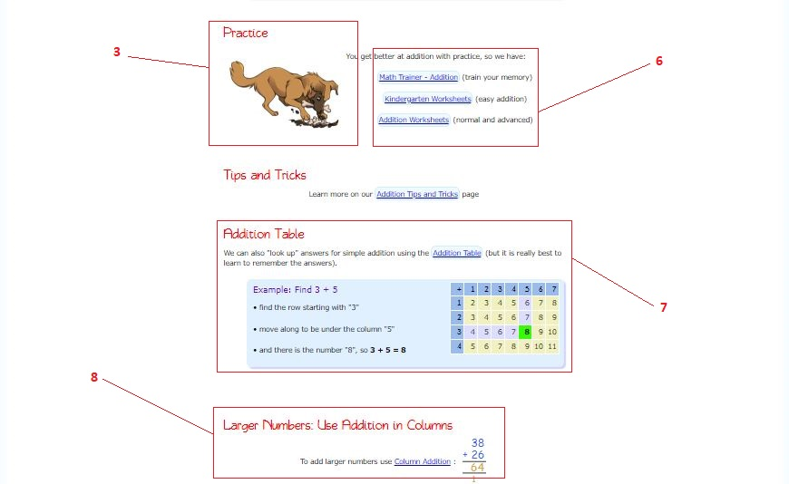

**Math Trainer:** <https://www.mathsisfun.com/numbers/math-trainer-addition.html>

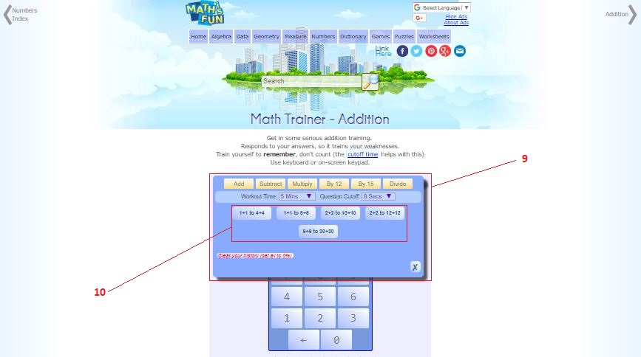

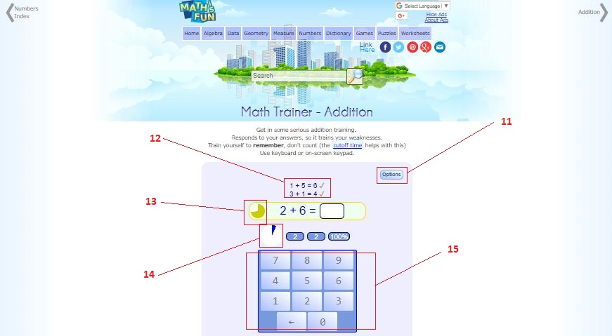

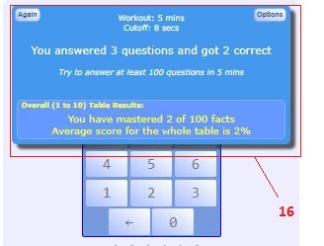

**Column Addition:** <https://www.mathsisfun.com/numbers/addition-column.html>

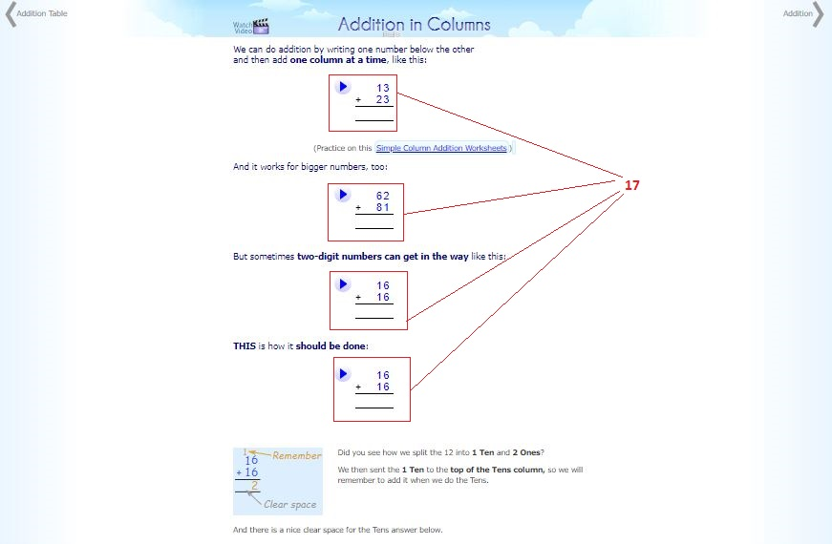

Math’s Is Fun – Pro’s!

1. Website Logo has a Fun design supporting the name of the website well.

2. Menu options with images to better illustrate individual options.

3. Child-friendly images to support and create a more fun, colorful learning environment.

4. Examples immediately after any information is explained.

5. Letting the learner have a small simple first go at doing the task being taught.

6. Offering further practice training and topic related printable worksheets.

7. The inclusion of tables such as Addition, Multiplicity and Subtraction Tables.

8. Progression to the next step for any particular topic of learning.

9. Built-in math trainer, usable for practice at each individual own pace or a controlled speed developing pace, and various customizable options, supporting the 4 basics, addition, subtraction, division, and multiplicity.

11. Ability to modify Math trainer options during gameplay.

12. Shows a brief history of previous equations completed successfully or incorrectly.

13. A visual timer to show how long is left to solve a single equation before the answer is shown.

14. A visual timer to show how long is left in the training round.

15. A number pad to click and input answers to equations with, great to support touchscreens!

16. Shows the settings for the round played and the results.

17. Visual short video clips to visualize the illustrated instructions about how to do the task taught.

Math’s Is Fun – Con’s!

10. Only a few preset options in Math Trainer could be better with more customizable number ranges.

18. No image for this because it just doesn’t exist, No Accounts or Login support to track progress or keep records of achievements and statistics for individual learners using the website.

Math’s Is Fun – Summary

This is a Fantastic website to go and learn about Mathematics. It is filled with many useful examples, and tip or tricks, tables, worksheets, visual demonstrations and was found to be very clear in the way it teaches. The Math Trainer is a fantastic little tool that has a lot of potential uses and benefits such as helping to memorize common simple equations, develop speed training to solve equations faster, or practice generally without time constraints and more.

The website seems to cover Mathematical material for all age groups, but while it can be a useful learning platform, it is lacking some fundamental elements in functionality especially regarding the persona's needs and wants that have been identified.

**Website:** Mathopolis

**URL:** [www.mathopolis.com](http://www.mathopolis.com)

**The Idea:**

“The idea behind the site is to make mathematics fun through challenging games and quizzes.”

**General:**

“The main content of the site is aimed at basic math skills. However, you will find some more complex stuff and some easier bits. Hopefully, there should be something for everybody.”

**Quoted from:** <https://www.mathopolis.com/about.php>

**Home Page:** <https://www.mathopolis.com/index.php>

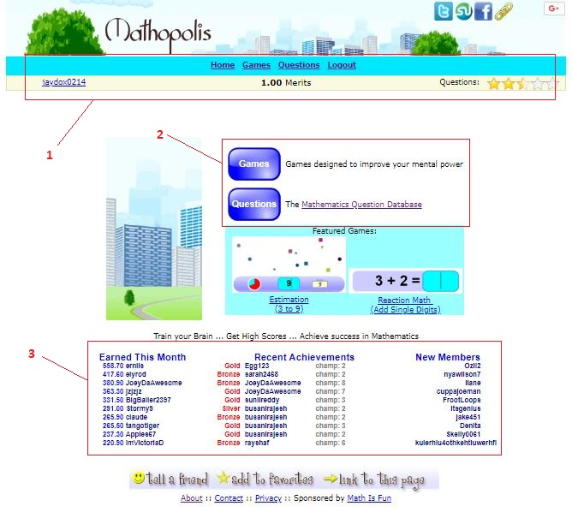

**Games Area (Numbers):** <https://www.mathopolis.com/list/mind-numbers.php>

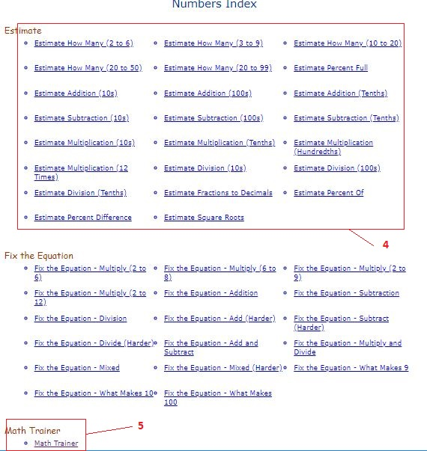

**Math Trainer:** <https://www.mathopolis.com/games/math-trainer-all.php>

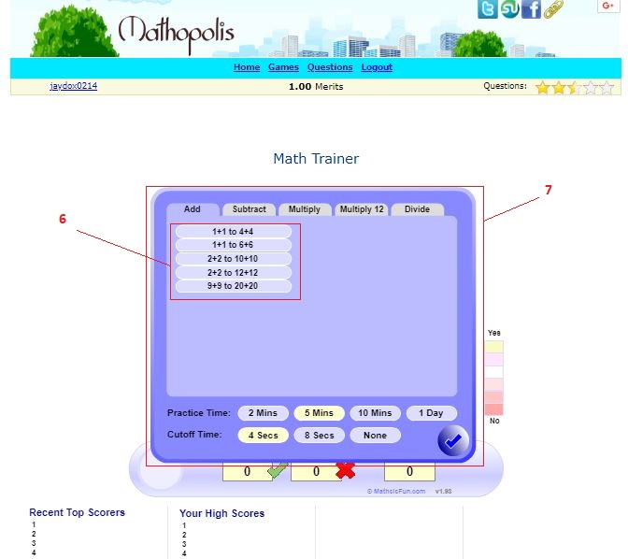

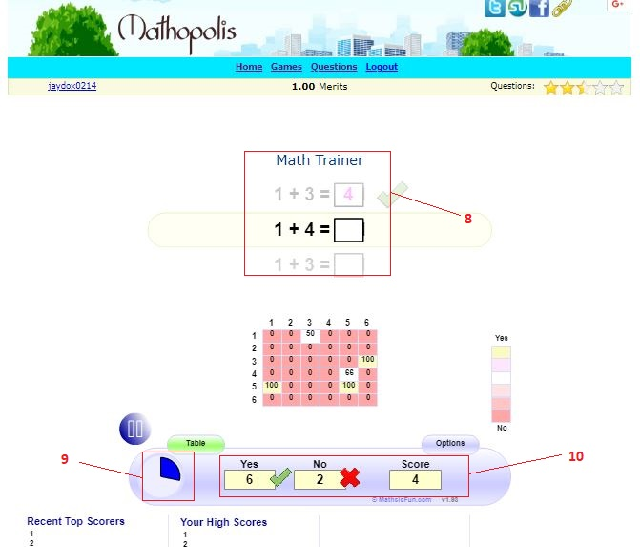

**Questions Area:** <https://www.mathopolis.com/questions/index.php>

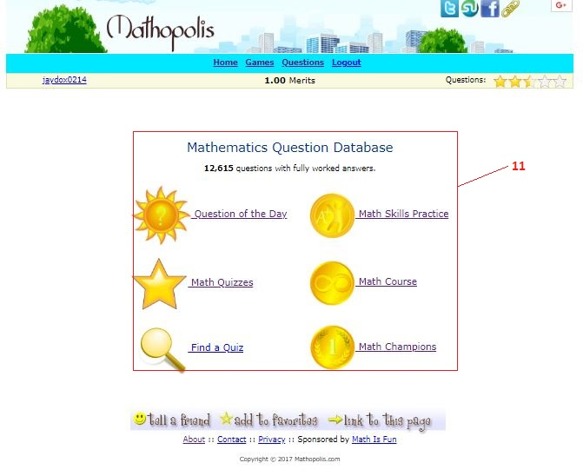

**Math Courses:** <https://www.mathopolis.com/questions/course.php>

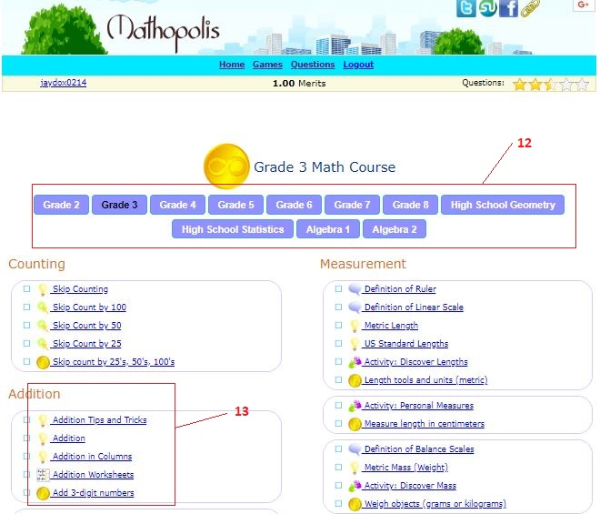

**Math Quizzes:** <https://www.mathopolis.com/questions/quizzes.php>

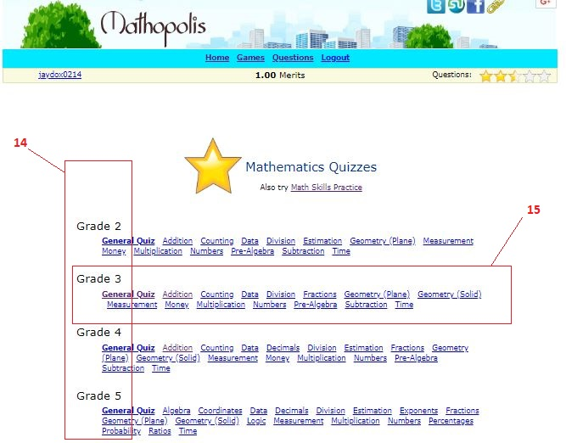

**Math Quiz:** <https://www.mathopolis.com/questions/q.php?id=9841>

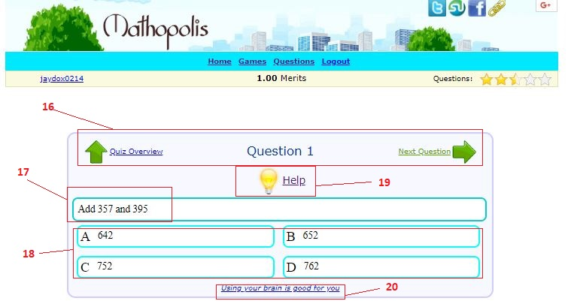

Mathopolis – Pro’s!

1. Support to login accounts and see stars, merits and medals earned if any.

3. Statistics shown on homepage from leading, recent and new learners.

5 & 7. Provides a Math trainer game almost identical to that seen for Math’s Is Fun, supporting Addition, Subtraction, Division and Multiplicity at customizable lengths of time for round duration and per equation to solve.

10. Math Trainer shows a score calculated by how many answered correctly minus wrong answers.

11. Questions area has a menu with visuals to help illustrate the navigation menu for this area and provides a good selection from the question of the day and quizzes to online math courses.

12. Math Courses are offered on a per grade basis making it easier for learners to go straight to material relevant to the level a learner is at.

13. Math Courses are well separated into each math topics subcategories.

14. Mathematics Quizzes are offered on a per grade basis making it easier to test and practice at a suitable level for where the learner is at in their education.

15. Math Quizzes are well separated into each math topics level taught at any given level.

16. During the quiz, learners can navigate back or forward through the questions.

17. Showing the equation as a kind of question format, this is good but lacking at the same time too.

19. Help is available if needed, this Is a good support system during a quiz for struggling students.

20. Little constructive messages placed here or there never hurt anybody, good idea.

Mathopolis – Con’s!

1. Even with the support of an account to login, there is no account management, grouping or task setting, much statistical information or history. It falls short of providing much of the functionality desired by the personas identified.

2. Untidy overall and has two buttons leading to the same places as offered by the navigation bar.

4. There are many math game options, but all so similar and just slight differences looks very messy and boring on the page.

6. The Math Trainer has the same issue seen at Math’s Is Fun, the number ranges for equations are set out as defined options to click a button for, this could be better with customizable number ranges.

8. Math Trainer game shows the last equation (and if correctly answered), the current equation and the next equation coming up. While listening for keypad number presses on the Users keyboard to input the answers! This is not good because it will not support touchscreens or mobile phone users well, and is not good to show the next coming equation either.

9. Math Trainer only shows how long is left for the current round, but not showing how long left to answer the current equation.

17. The display for the equation in question format is possibly not good for younger targets, I think it could be presented better in column format. Also noticed the equations never change, they are fixed not generated, enabling memorizing correct answers.

18. Multiple choices are not that good, because it allows for the chance to cheat by spotting obvious ones that will not be the answer, allows memorizing answers as all are fixed not randomly generated and has no support for learners to show their work on equations, this can be all improved.

Mathopolis – Summary

The website Mathopolis has been created with the intent of replacing Math’s Is Fun! But it appears that the developers have missed the mark. While they still offer a lot of the great learning and separated a lot into the many different grades of learning, it just all looks a bit messy and a lot less fun on screen!

They have the account registration and login support which the personas are looking for but missing so much in the ways of account management and statistics on learners, no control over anything offered for teachers or parents, no task setting or history and cannot create your own quizzes. There are plenty of functionalities missing preventing it to be the best option for target audiences.

Competitive Analysis Summary

The Math Trainer was worse than the original provided at Math’s is Fun! And Mathopolis just feels like a less comfortable place to be than the old original Math’s Is Fun. While Mathopolis attempts to bridge the gap between what was clearly missing, it fails to do so likely through lack of website analysis done during development.

It seems such a shame to waste what has such good material by not having it be all it can be! I would like to take all the Pros of each website, drop all the Con’s, making improvements to support the identified functional needs and want of all 3 personas with the ultimate end goal of becoming used by all schools and parents around the world.

# Site Content

## Identify Content and Functional Requirements

Home – This area will provide encouragement towards joining up and learning mathematics, with some general information about what the website has to offer to its audiences, and display website statistics with support to login or register in the upper right corner.

Login – Registered users can login and will be redirected to a learner or educator panel depending on the type of account the user has and see options accordingly. Changes to Logout once Logged in.

Site Statistics – Various information about recent user registrations, achievements, and top scores.

Math Trainer – A game based on the Math Trainer from Math’s Is Fun but improved to be more customizable.

Account Management – Logged in accounts can go here to update profile details or change password.

Profiles – Users will have a public profile that anyone can view.

Learners Area – This is the section reached after a learner logs in and provides links to tutorials, the Math Trainer, useful links, Statistics for the individual learner and a history of tutorials and work did.

Individual Statistics – These show the learners recent scores, best scores and progress history.

Educators Area – This is the section reached after an educator logs in which could also be a parent figure and provides an overview of learners being managed, groups and statistics for those groups. The educator will also be able to initiate tasks for groups, define custom quiz settings for assigned tasks and give feedback to learners or groups.

Group Statistics – This will be an overview of a group's recent activity, scores, best scores, and progress.

Tutorial Lessons – These will be Mathematics Topic-specific tutorials aim at teaching the knowledge and skills needed to do Math Topic equations aiming at making it fun and interactive.

Custom Quizzes – Educators can setup Customized Quizzes to assign to Groups as a task to complete.

Generated Quizzes – Educators/Learners can use automatically generated quizzes to practice Maths.

Group management – Educators can add or remove Learners from groups.

Completion History – Educators/Learners can see a history of Quizzes and Tutorials completed.

DYNAMIC CONTENT:

Through the use of PHP, the website is being designed to be Dynamic, making the website able to control what is showing on the same page depending if the account logged in was for a learner or educator/parent. We can also Dynamically manipulate what statistics, history, feedback and more, are displayed to the user. Through the use of Model View Controller Information Architecture, views being the output seen can be manipulated according to the model data accessed by the controller.

The navigation bar and login panel will change dynamically too according to the state of login and type of account logged in, showing different options accordingly.

# Site Structure

## Architectural Blueprint

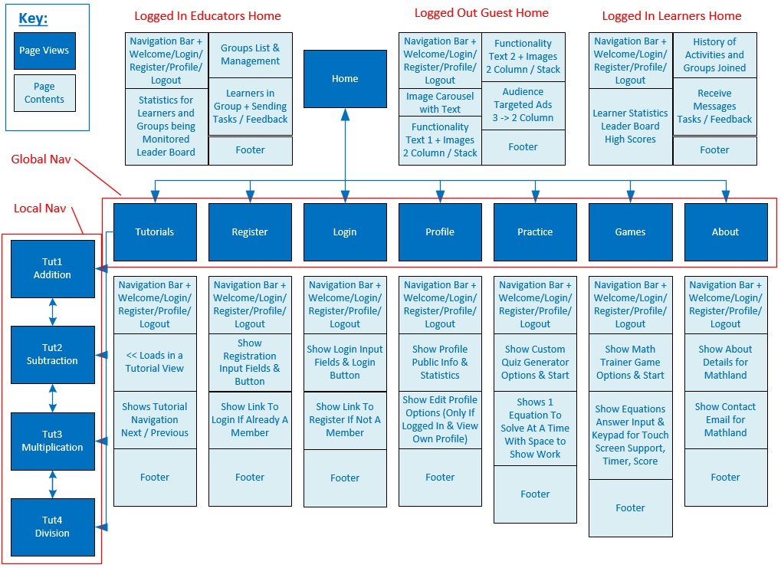

The Dynamic Navigation Bar with Welcome/Login/Register/Profile/Logout and the Static Footer are Secondary Views that all Primary Views will import to display making them reusable/editable from one location, avoiding repeating the same fragment of code over an over.

## Define navigation

Global Navigation

A Learner or Educator/Parent will be able to navigate the website using a global navigation bar that exists at the top of every View. The navigation bar will provide linking to the following:

* Home
* Tutorials
* Practice
* Games
* About
* Login
* Register
* Profile
* Logout

These are the main views as seen in the Navigation Blueprint plus the addition of ‘Logout’ which actually logs out the User and directs them to the Login view.

Important to note is that the Login & Register linking only shows when not logged in on the Navigation bar, and then when logged in this is dynamically changed to show Profile & Logout.

Local Navigation

The Tutorials view will contain Navigation between various Tutorials and those are only available locally to the view and not from any other views. Supporting going to the Next or Previous Tutorials. These are easy to see going down the left side of the Blueprint.

# Visual Design

## Layout Wireframes

Below are the Wireframe Layouts for ‘Mathland’. Yes, the name for this website has been decided. All Wireframes where designed and built using the free website <www.wireframe.cc>. These 8 Wireframe pages begin to visualize the Home, Tutorials, Practice, Games, About, Login, Register & Profile views.

**Navigation Bar & Footer:**

The Navigation shows a Logo, Global Navigation links and a Welcome message for Guests or Logged in users, and then depending on login state displays either the ‘Login’ and ‘Register’ linking or the ‘Profile’ and ‘Logout’ linking. I am explaining this now because it is reusable and will be implemented at the top of every page view, only needing to be described and coded out one time.

The Footer is also reusable and going to be imported to complete each view, so here it is being described only once. Seen in the Footer is Social Media external linking, Back to Top quick click support and Linking to download the Privacy Policy or Terms of Service.

**The rest of the view contents are self-explanatory between the Wireframes & Mockups!**

Home Page (4 Images)

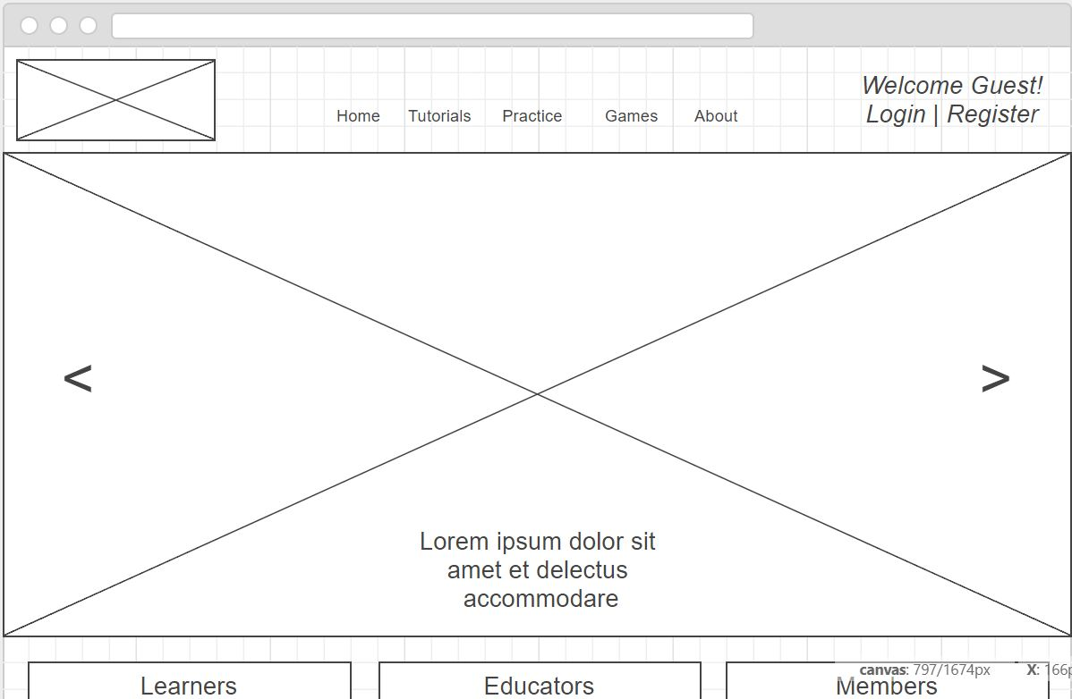

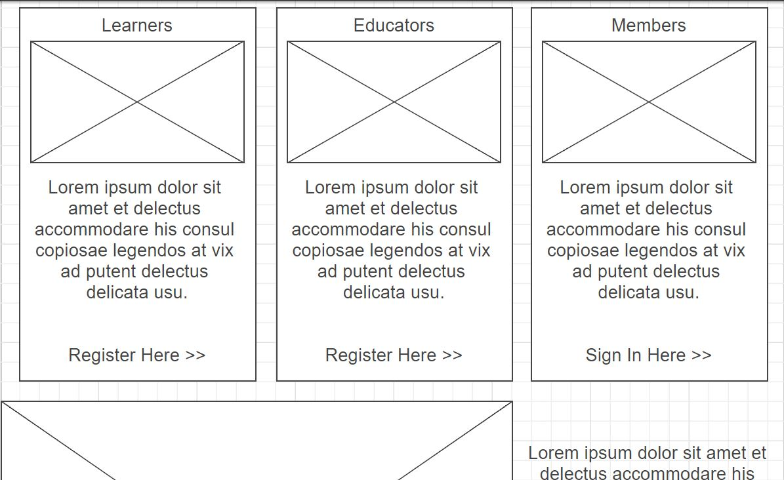

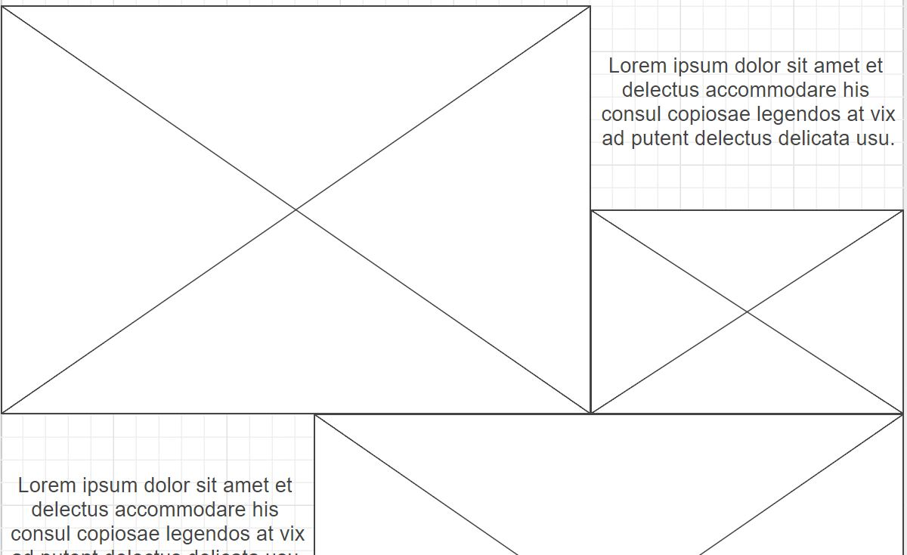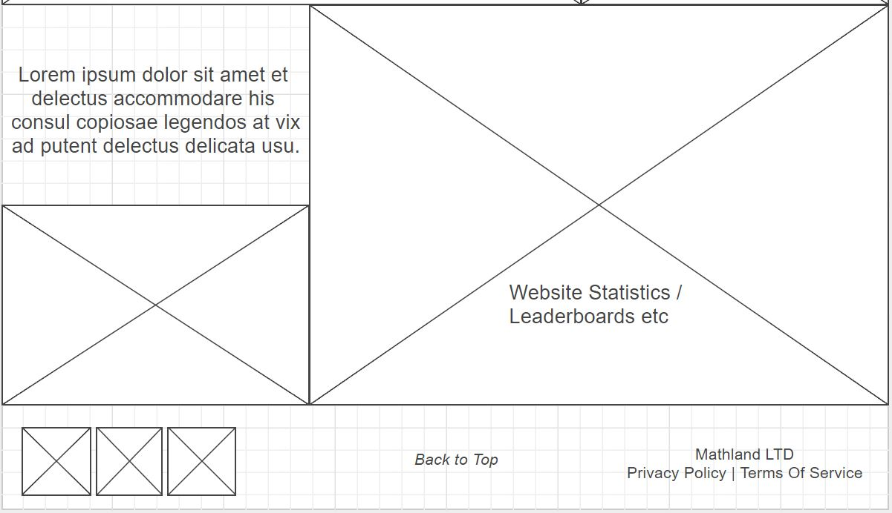

Register

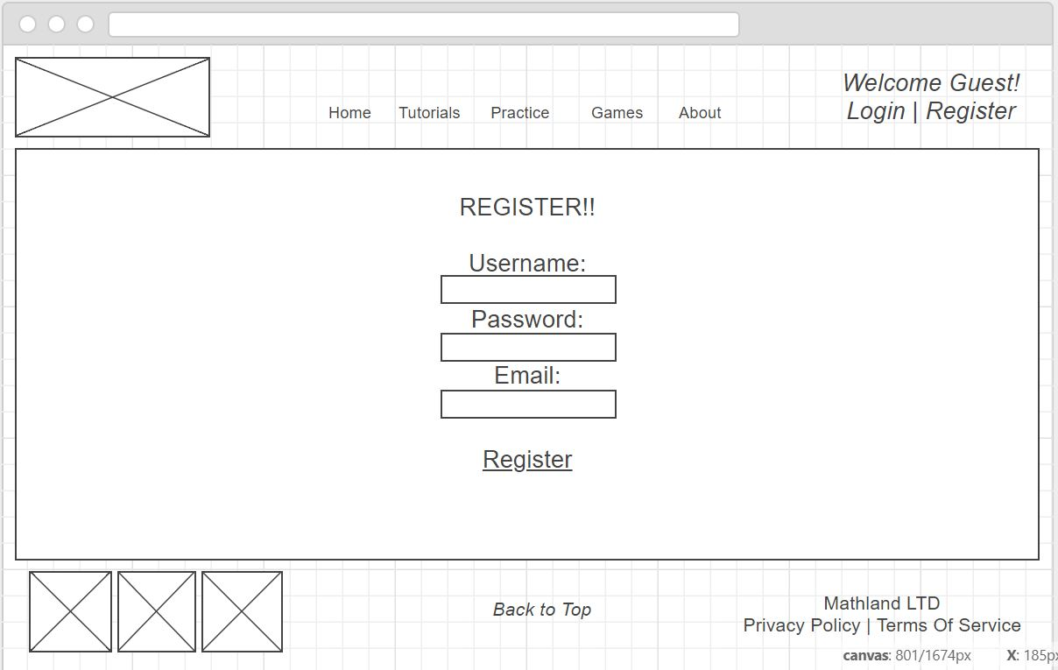

Login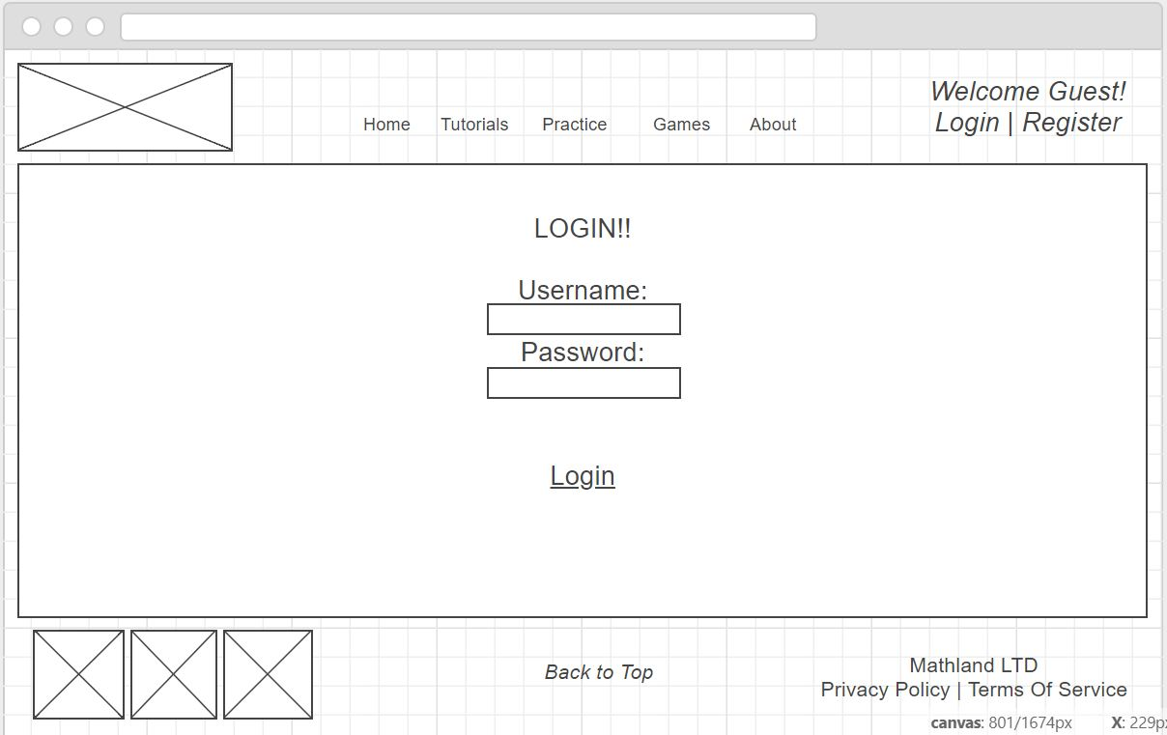

Profile

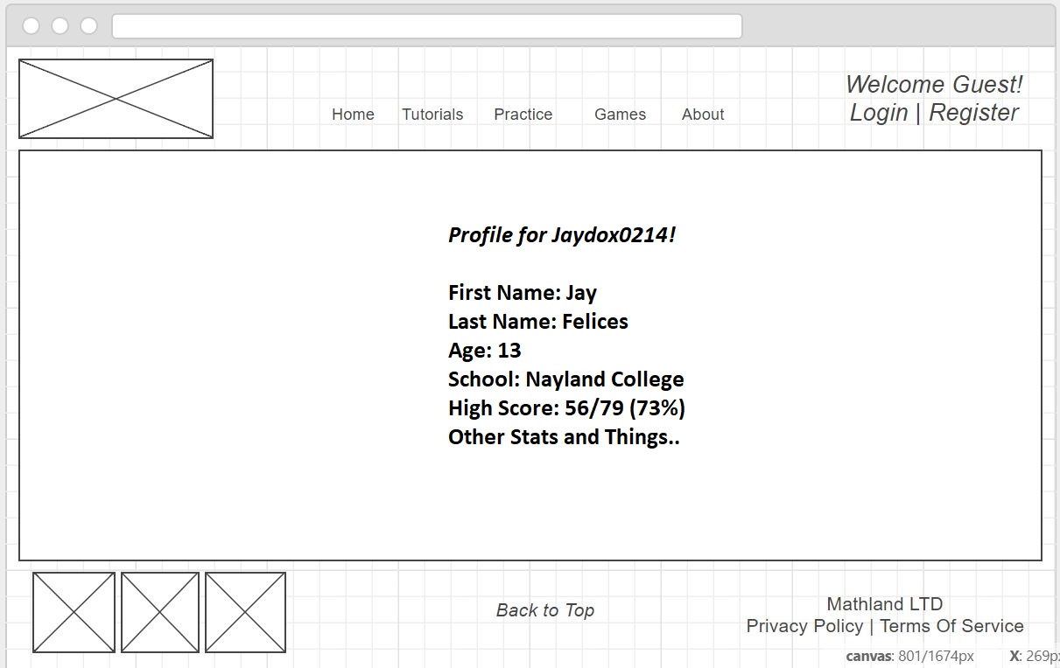

Tutorials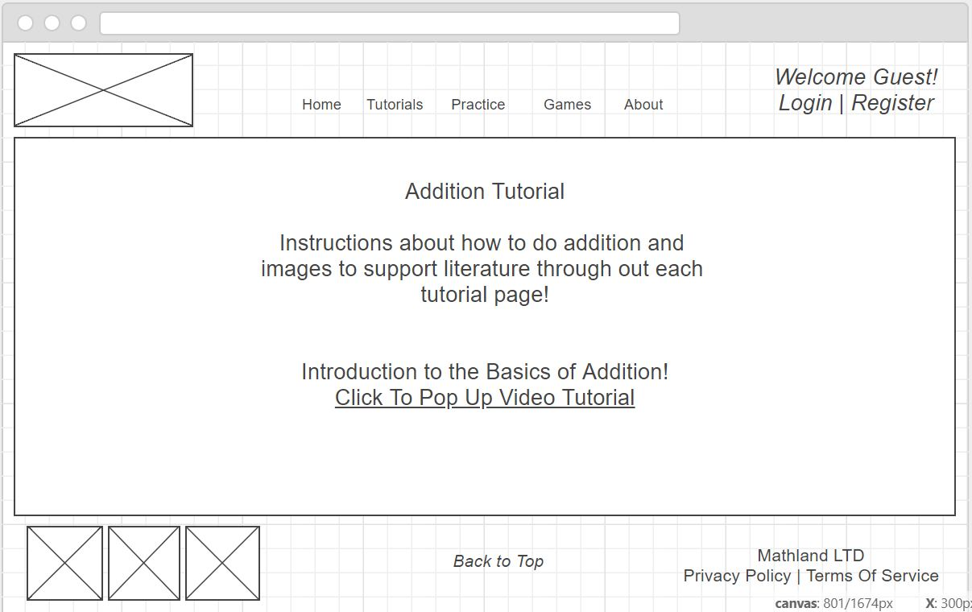

Practice

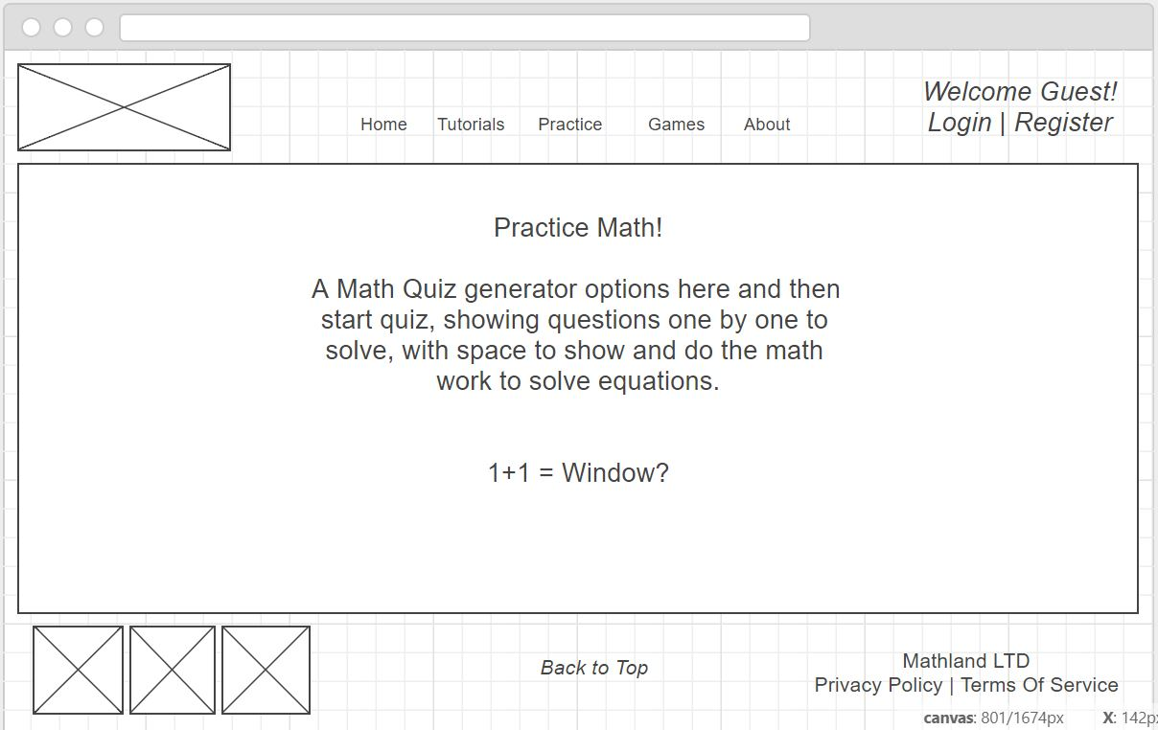

Games

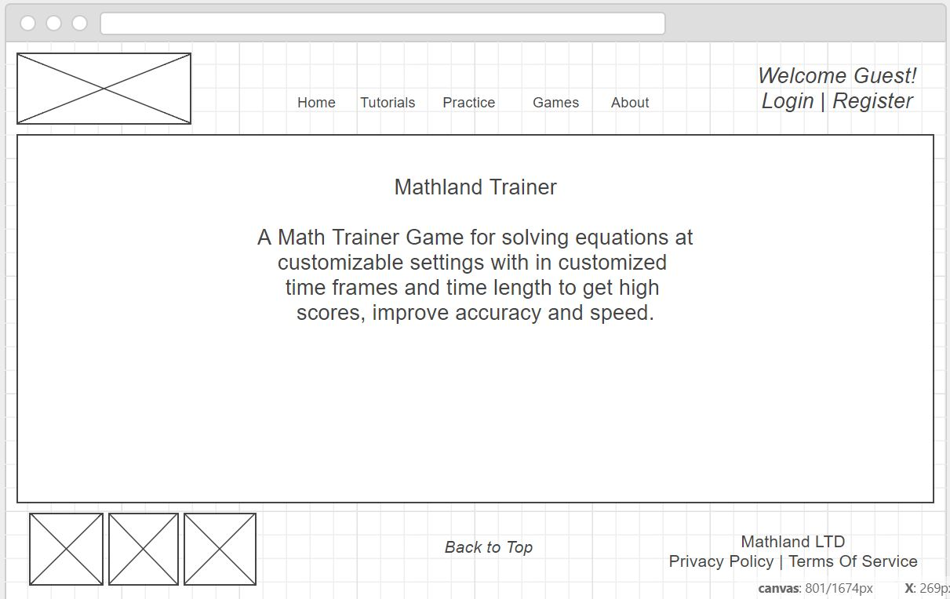

About

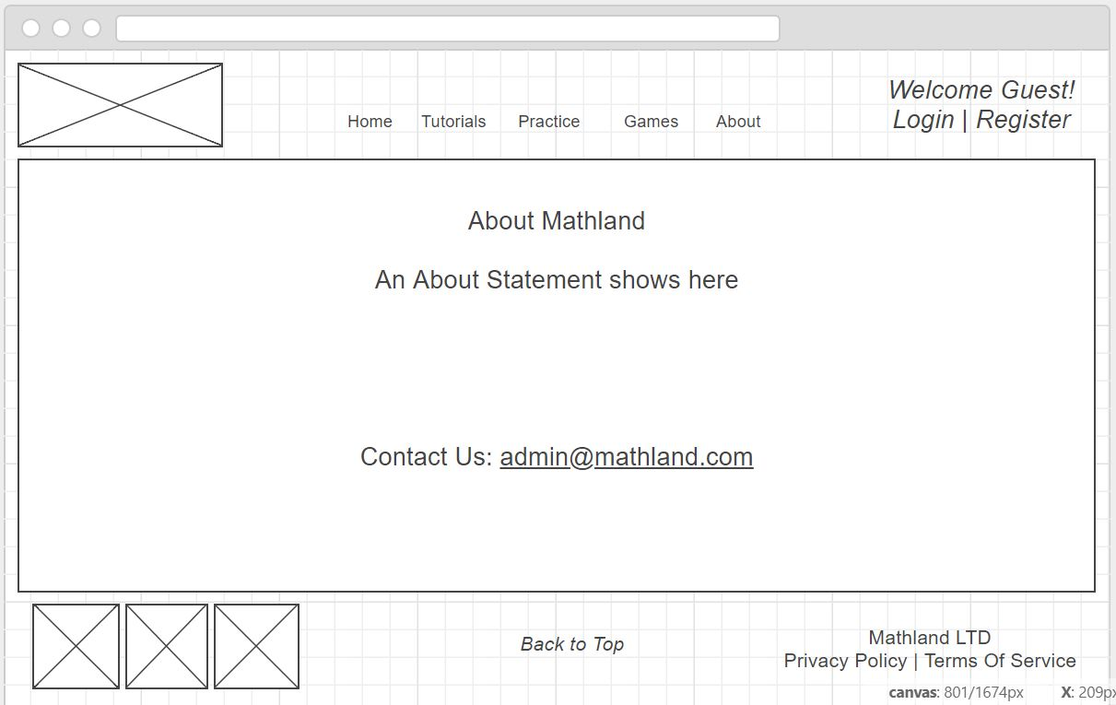

## Design Sketches and Page Mock ups (in HTML,CSS,PHP,JS)

The Mockups have been designed based on the Wireframe Grids, and Coloring is being kept neutral with a white background and use of red, black, blue and silver for fonts. This allows the images that will be later added to really pop from the screen and provide the coloring and graphical content for views.

The Information Architecture is designed using MVC (Model, View, Controller) and the languages HTML, PHP, CSS and JS to support in page manipulation, dynamic web page content, styling, sizing and making the website responsive for cross-platform use.

Same as the Wireframes, all pages share the same Navigation Bar and Footer, while behind the scenes they all share the same HEAD information too. Persistent Data has been implemented through the use of Sessions. This supports the testing of Registration, Login, Dynamic Content and Profile Editing.

Same as Wireframes the Mockups show 8 various views across the website and some mock-up content is shown but not final, while other parts not yet decided or designed and coded out have text stating what will later be seen in that part of the view.

Home (4 Photos)

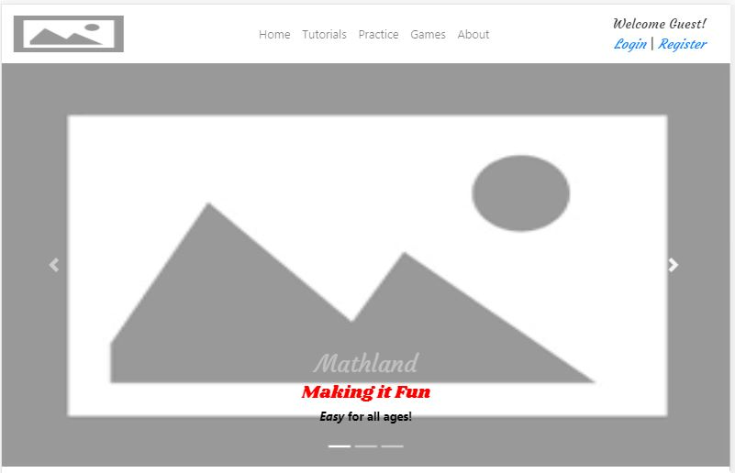

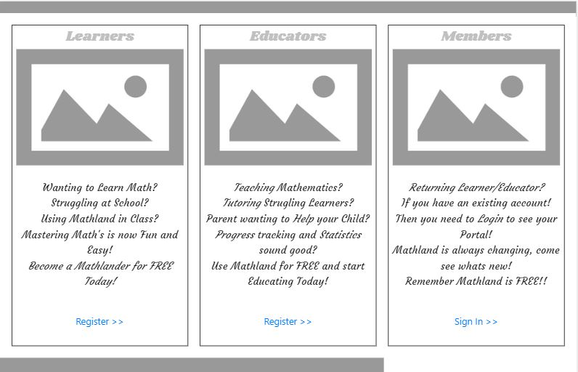





Register

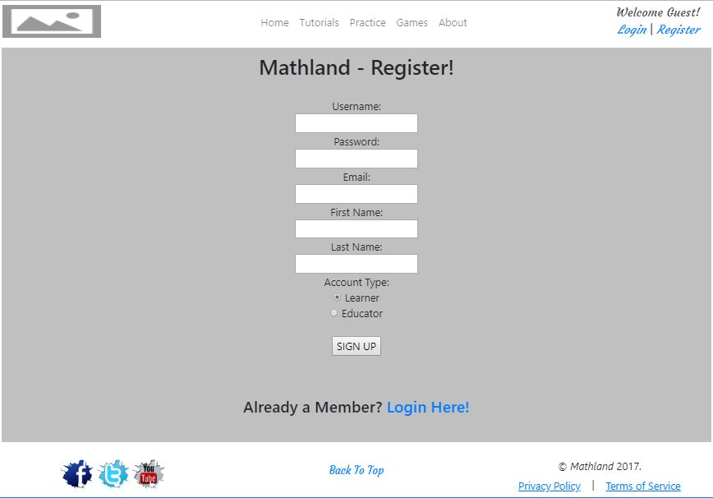

Login

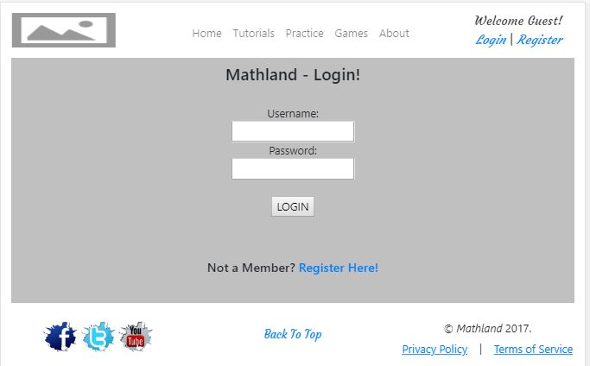

Profile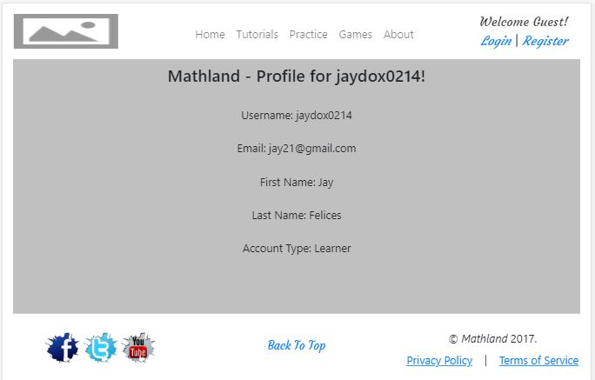

Tutorials

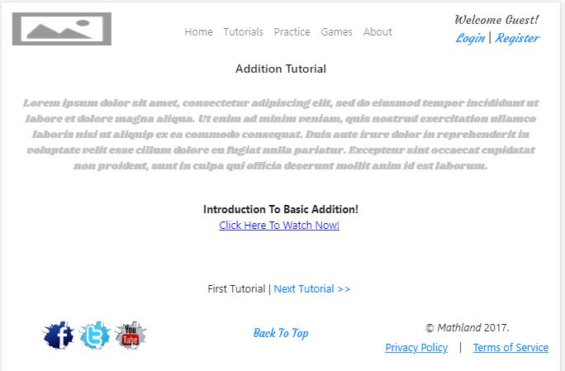

Practice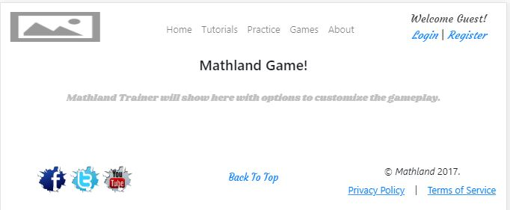

Games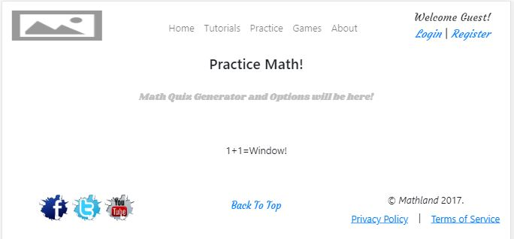

About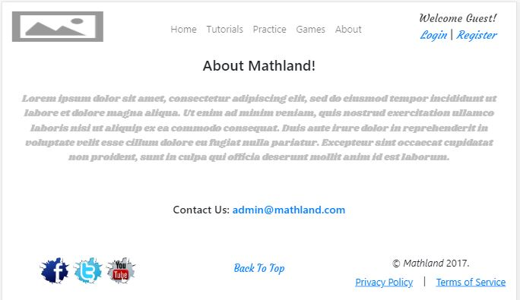

MODELS / Views / CONTROLLERS:

Models:

UserModel.php

TutorialsModel.php

Views:

Home = HomeView.php

Tutorials = TutorialView.php

Practice = PracticeView.php

Games = TrainerView.php

About = AboutView.php

Register = RegisterView.php

Login = LoginView.php

Profile = ProfileView.php

Controllers:

CompController.php

LoginController.php

NavController.php

TutorialController.php

# Updates to Information Architecture for Milestone 2

Models: CompetitionModel.php, QueryModel.php, DBconnection.php

Views: Competition = CompView.php Controllers: CompController.php

## Creating & Connecting the Database

First off, the Database was designed, built and tested with data to get it up and operational for development and testing phases of the Database implementation. Then used the Database Connection PHP file provided to do connections from models but added a few extra functions to the PHP file for things such as getting the Number of rows returned or affected rows.

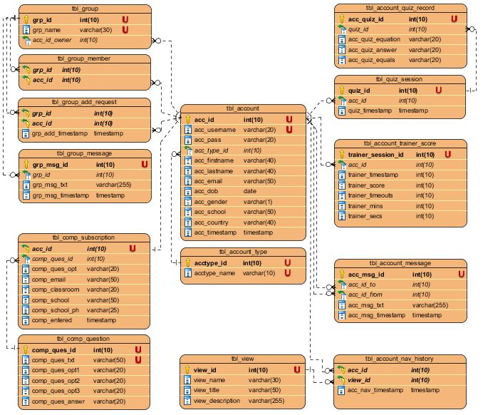

## Implementing Login & Registration through the Database

Next was getting the Login and Registration working, while adding additional data fields on the registration form to support all fields identified when the database schema was formed, and can proudly say it is all through the database now, to register new accounts, login existing accounts, handle failed registrations or logins, and still using Sessions to retain the knowledge of who a user has logged in as while navigating the website.

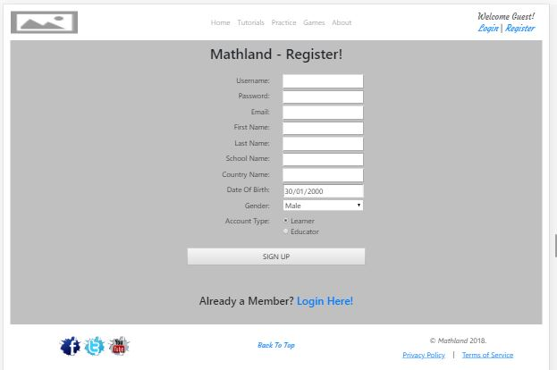

## Implement a Competition Form & Thanks

Milestone 2 requires a competition that students can enter to be in the draw to win a computer for a nominated school of their choosing, so to do this firstly the Form layout was developed and since the database design has the required tables for competition questions and subscriptions there was no need to do this thanks to future proofing earlier on in the assignment.

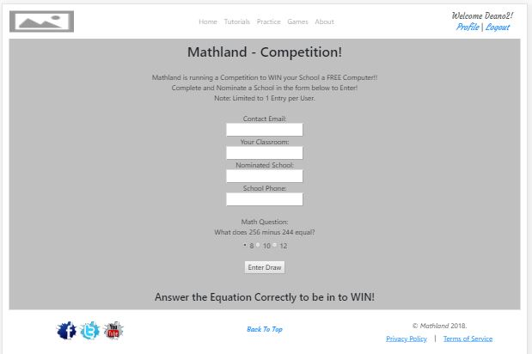

It's important to note that all subscriptions to the competition must be from Mathland user accounts and limited to only one entry per account! If a user not logged in tries to navigate to the competition form they are redirected to the login page, and instead of making two views one for the subscribe form and another for the thank you page after entering the competition, there is a dynamic competition page that when loading first checks if the logged in user has previously entered the draw, if so the page displays thanks message and details used to enter the draw! If the user has not entered yet then the single view instead returns the entry form to the draw, this is done dynamically with the help of a simple IF statement and PHP.

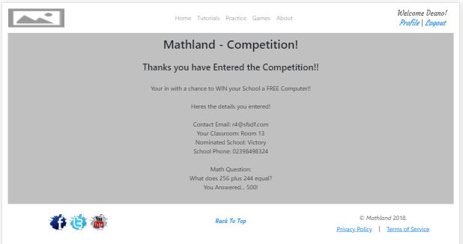

For Milestone 2 there is only a static linking to the competition somewhere on the website, It is on the home page under the Nav bar as a Bootstrap Alert, with a clickable link to the competition and support to close the alert too. For this, the code was sourced for a bootstrap alert from W3Schools.

<https://www.w3schools.com/bootstrap/bootstrap_alerts.asp>

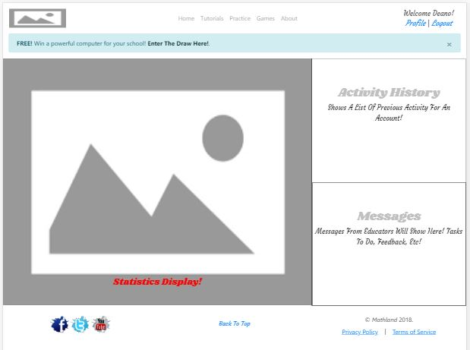

## Time to Play a Game?

So for the Game section of Mathland there is a Math Trainer Game with a bunch of customization options to make it suitable for all ages and stages of basic mathematical learning, like that found on a Math website during competitive analysis, just more options to customize it further, to ultimately create a newer improved math trainer for users of this project.

Not having a lot of experience with JQuery, so existing JQuery related Math Trainer examples were found and modified to include an additional timer for counting down a limited time to answer each question before the correct answer is then displayed, in conjunction with the existing overall time frame for the trainer to run that was in the example source. As simple as that might sound it took a good 6 hours to get it working. Have also added more statistics to record and display during and after gameplay and display of details about the user playing.

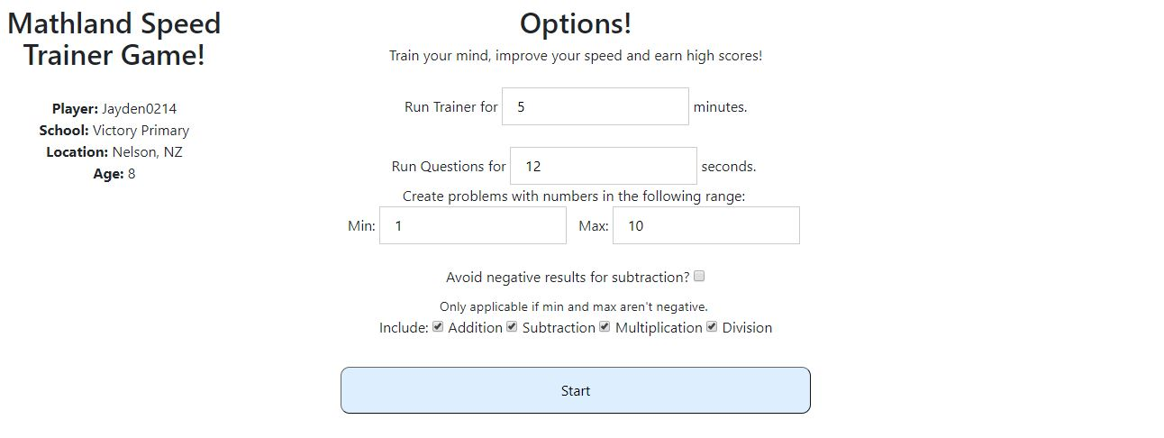

Then studied the other trainer example to see how it was doing its number pad buttons as a way of answering the question from a touchscreen device and built a Numpad for the Math Trainer that can also Hide or show depending on if needed, then implemented bootstrap rows and columns and a bit of styling and size control.

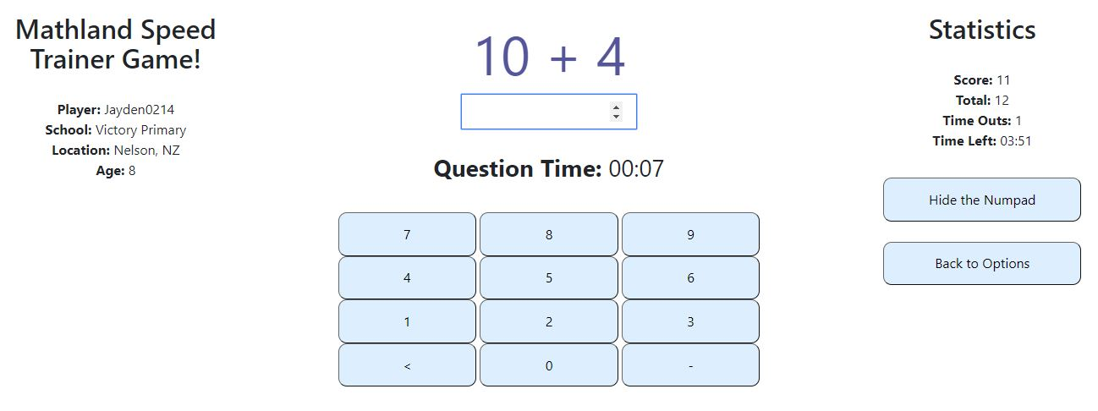

**Math Trainer source example on Github.**

<https://github.com/ljacqu/mathtrainer>

**Enhancements to original source code:**

Additional TextBox in options for setting how many seconds per question! Previously you had no time limit per question at all, the game would just end when the total minutes per game was up.

Added variable for recording How many times the player Timed out. This means the player failed to answer the current equation in the specified time frame allowed per question, and that the Answer to the question has been shown to them!

Addition Timer added which is influenced by the Textbox added to control how many Seconds to answer each equation, this Timer counts down towards displaying the correct answer and recording in the additional Variable a failure to answer fast enough ( Meaning player just Timed out/Wiped out).

Addition of Displaying Seconds Remaining to Answer per Equation, and Display the Statistics for how many Timeouts a player has experienced.

Modified Statistics Display, and Game over message Display!

Addition of a Numpad that can hide and show to better support use of this Math Trainer on Touchscreen devices.

Introduced Bootstrap responsive rows, columns, scaling and styles!

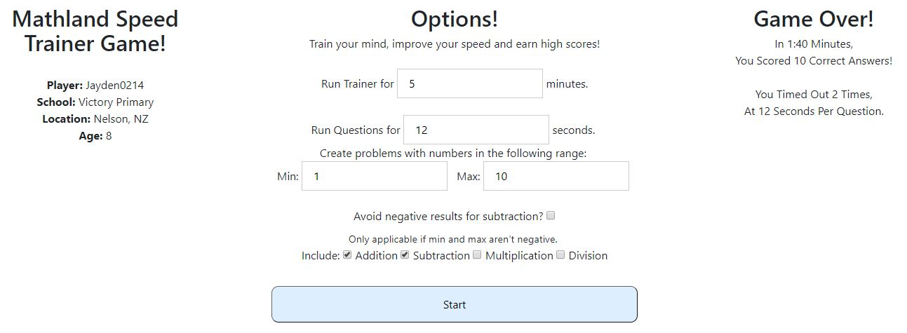

## Updating Account Profiles through the Database

Finally got the Profile related functionality up and running through the database, to display your own logged in account details, allow the editing of one's own account information, and separately the option to change password which was combined originally.

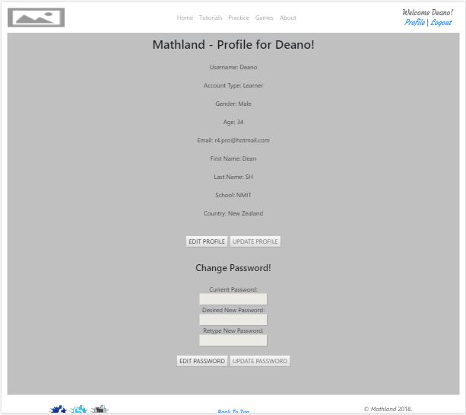

This feature also supports looking at the profile of any other member but when doing so strips out dynamically any of the editing account information form code and buttons so they do not exist in the view display.

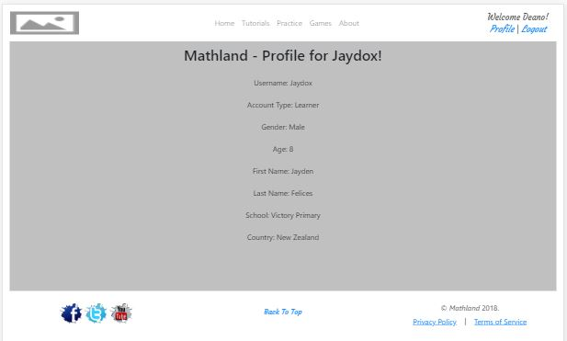

And implemented procedural SQL Escaping to help protect from SQL injection throughout all the SQL queries which have been migrated and isolated into their own class called ‘QueryModel’.

# Updates to Information Architecture for Milestone 3

## Competition JQuery Animation!

For the JQuery animation that when clicked leads to the Competition entry page or displays thanks with previously entered details, It was designed weeks ago and has just been waiting for milestone 3 to come around so to implement this stage of the project!



The “Enter Competition Now” star bounces around the screen from left to right touching the top at some random point along the way, then goes off screen to touch a random point of the right side of the page, before going from right to left the other way, touching the bottom area again at a random point before going off screen again to the left this time, and then repeats, but always flowing towards a random point and with a swing effect speeding up and slowing down as it flows along each point to point.

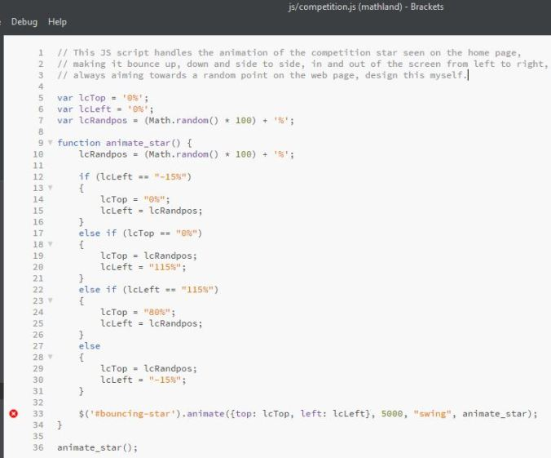

This always shows on the home page, logged in or not, but if clicked when logged out, it leads to the login page, if logged in it leads to the entry page, unless already entered then the thanks page displays.

## Tutorial Comments & First AJAX

Mathland has a commenting system which displays as a list with a scrolling box, showing the username of the account which commented, the date and time along with the comment message, with the usernames being clickable to go directly to that user's profile. These comments display according to the Tutorial subview that is being currently viewed, so for each Tutorial, a separate set of comments is shown.

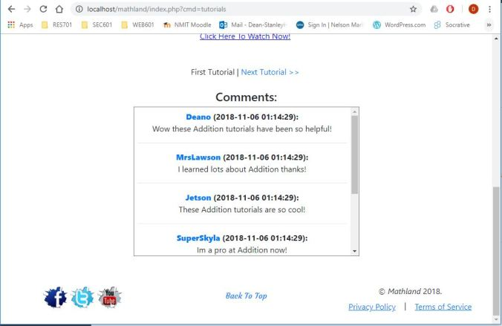

The comments are stored in the database, and as seen in the above image, when no account is logged in the visitor cannot post any comments. Since comments are linked to user accounts the comment input text box and submit button will only display if an account is logged in, much the same as Practice and Games sections on the navigation bar does not display to a logged-out visitor.

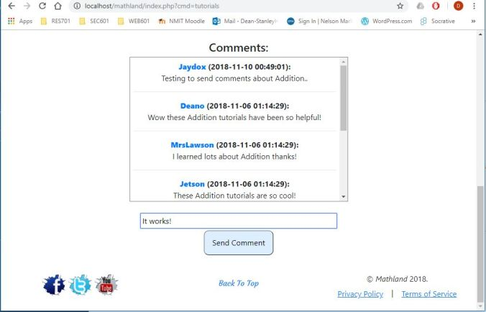

But once logged in, as seen in this image above, there is a text box for typing a comment and then a button to send it. For these two elements, it was decided not to use a form for learning purposes of how to do this without a form since most other places on the website already post data using forms. The comments display, in a descending order. So any newly posted comment will display at the top of the list, noticeable by the timestamps.

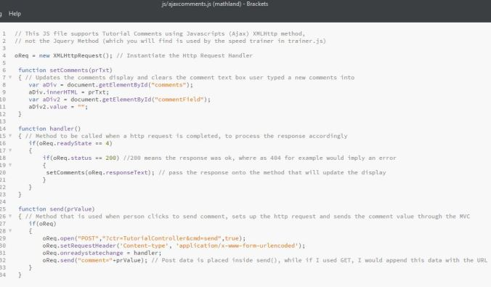

For posting comments Mathland is using Javascript alone for the AJAX (XMLHttpRequest) which was modified from GET to POST and this gives more flexibility with how a web developer wants to process different kinds of web server responses such as Error 404 code and more.

## Form Validation & Accepted Examples!

So now it is Validation time, Mathland has complete Form validation for all Forms in the website, Login, Register, Profile edit, Password change and Competition Forms. To manage this a bit better, all methods for validating each Form have been stored in a single Javascript file which is simply loaded into any view that is using a Form validation method, but the focus for validation was the Competition Form, so let’s take a look at the code for this.

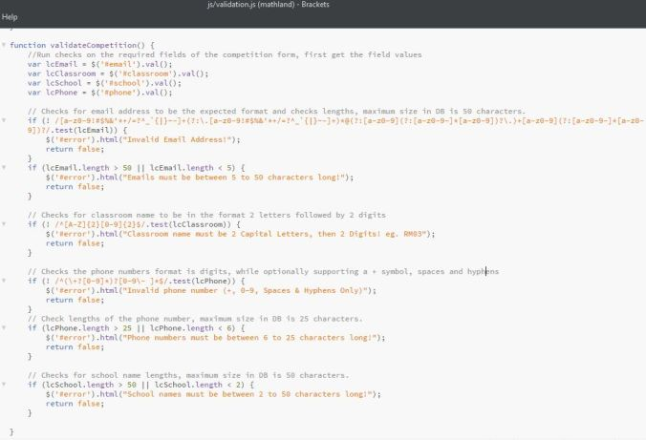

There are 4 required fields that need to be validated and these are **Email, Classroom, School and Phone number**. Three of the fields have simple minimum and maximum length checks, which is the only check performed to validate **School names**, but **Classroom** does not need to check lengths since it must be 4 characters long the Regex test for 2 Letters then 2 Digits all ready confirms a length of 4.

To handle phone numbers the decision was made to allow input of a single + symbol optionally at the start of a phone number, while allows Digits (0-9) and use of spaces or hyphens to more clearly separate phone number sections such as country code and area code, altogether supporting international phone numbers. Emails are pretty much set up to allow “something@something.something”, which the last something can still contain yet another dot for domains ending like “mail.co.nz”.

**Example patterns for School field:** Anything between 2 to 50 Characters.

1. Victory
2. Victory Primary School
3. Nelson Girls College

**Example patterns for Classroom field:** 2 Capital Letters (A-Z) Followed by  2 Digits (0-9) with a total length of 4.

1. RM03
2. RM25
3. RM99

**Example patterns for Phone Number field:** Any Digits (0-9), spaces and hyphens are accepted along with an optional + symbol.

1. 021 128 5121
2. +64211285121
3. 64-21-1285121

**Example patterns for Email field:**“Something@Something.Something”

1. Todd.Cochrane@nmit.ac.nz
2. Todd-Cochrane@gmail.com
3. t@m.c

**NOTE:** While we can check everything according to email address standards, the only real way to validate any email is by sending it an email and reading the response from the email server for if it was successfully delivered, or better yet send a validation link in the email sent, that a user must navigate to, in order to activate their new account or email address change. But since Regex checking alone is not really reliable, Mathland has kept the checking simple and are aware it can allow for none existing domains and more, but believe basic email structure validation is all that is needed here, because again for true validation and email should be sent out to any email address being used to sign up.

**Example patterns for Usernames when signing up:**Usernames must start with a letter, and end with a letter or number, character allowed are A-Z,a-z,0-9, 3 underscores and a single dot. Usernames cannot exceed 20 characters, and underscores cannot be consecutively placed next to each other or next to a dot.

1. Todd.Cochrane
2. Todd_Cochrane_99
3. todd.cochrane_007

## Tracking User Navigation, Trainer Statistics and JQuery AJAX!

The last major requirement for milestone 3 is to track users, so to do this the website is recording all navigation activity for any logged in account, saving what pages they navigate to and what tutorials or whose profiles they viewed. At the same time, saving statistics such as score results from the math speed trainer game has been implemented and both navigation history and statistics are now displayed to any logged in learner accounts on the home page in scrolling list boxes with timestamps in descending order!

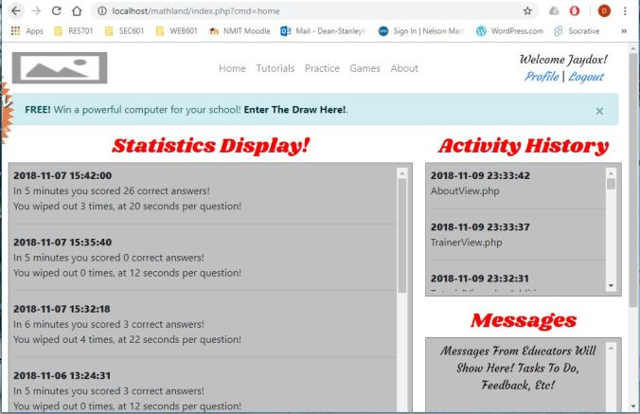

Being interested in the use of AJAX, a different approach was used than what is being executed for posting and updating the display of comments. Controllers are simply saving navigation history which each action through a controller, but in order to track speed trainer statistics the JQuery AJAX method was used to match the JQuery code of the speed trainer, whereby if a session ends from the runtime being up, or the user clicking the button to quit game, statistics are then recorded, and no display is updated since the display of statistics is only pulled from the database when navigating to the Home page where they can be seen.

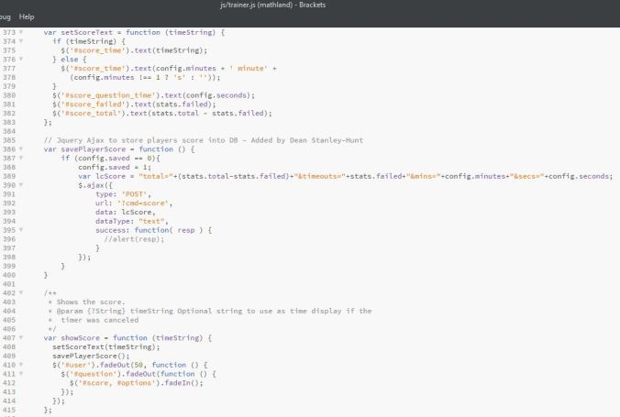

As you can see in the above image, once a response is returned for the AJAX, there is no code executed any further since the behavior expected is to simply insert the new statistical data.

## Pushing the Website and Database to NewSimland!

Mathland is now LIVE on the Internet at newsimland.com!

<http://newsimland.com/~Dean-StanleyHunt/>

After making all file paths in the code use double forward slashes, and changing the Database name and credentials that the DBconnection php file was connecting with, it was time to push this website live and online with a domain name for testing, rather than just hosting it myself and pointing to my own IP Address. To do this I connected to newsimland.com using FileZilla as my choice of FTP Client!

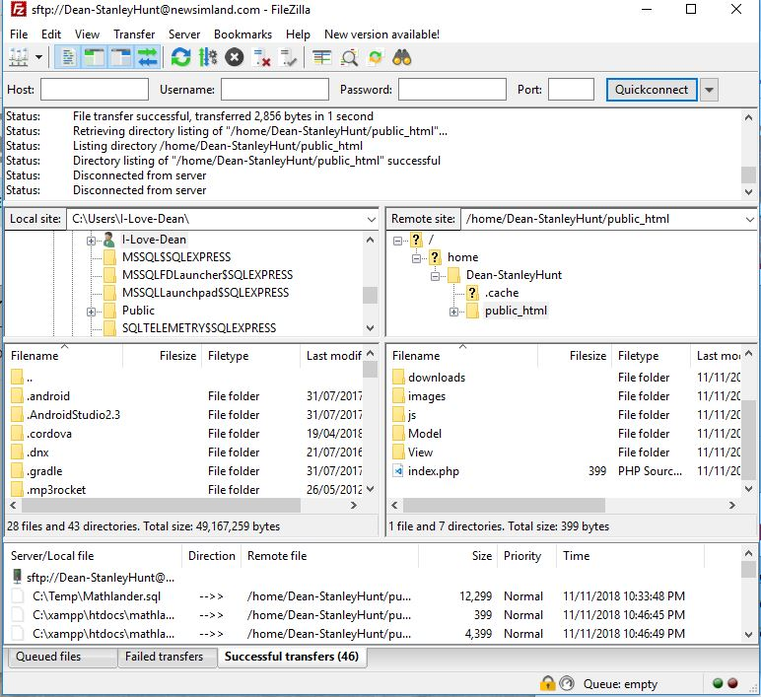

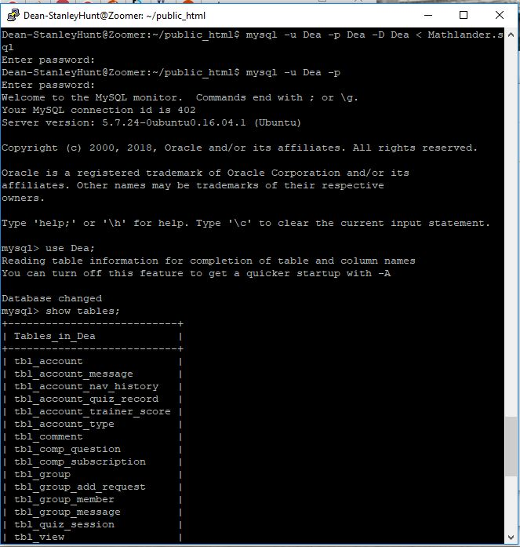

Also uploaded the Mathlander.sql file with all SQL required to create the database with test data inserted, then connected to newsimland.com using putty for SSH connection and changed the directory to public_html and executed a command to copy into mysql the content of the Mathlander.sql file and execute it successfully loading the database tables, references and test data!

Lastly was to verify the tables and data existed before then navigating to the Mathland website in chrome and starting to test if everything works as expected, and it did, so now Mathland is LIVE!!!

